When login Azure SQL database in SSMS, and see the following request, it means you need to set up a firewall rule in your Azure account first. This tutorial is going to show you how to set up a firewall rule. We will take the IP address on Utah State University main campus for example.

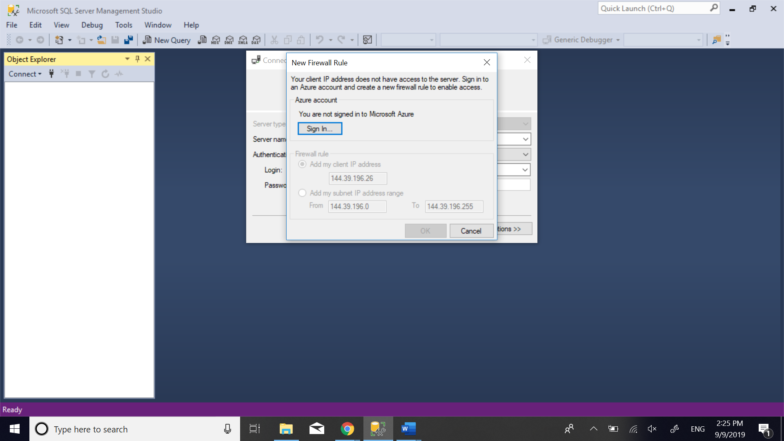

First, get the IP address for the place you want to set up a firewall rule. For example, there are two type of IP address for registered connection on USU campus based on [this post](https://usu.service-now.com/kb_view.do?sys_kb_id=183bc4d4b817c100bd5c10e091b7dbc8&sysparm_nameofstack=&sysparm_kb_search_table=) which is 129.123. * . * and 144.39.*.*.

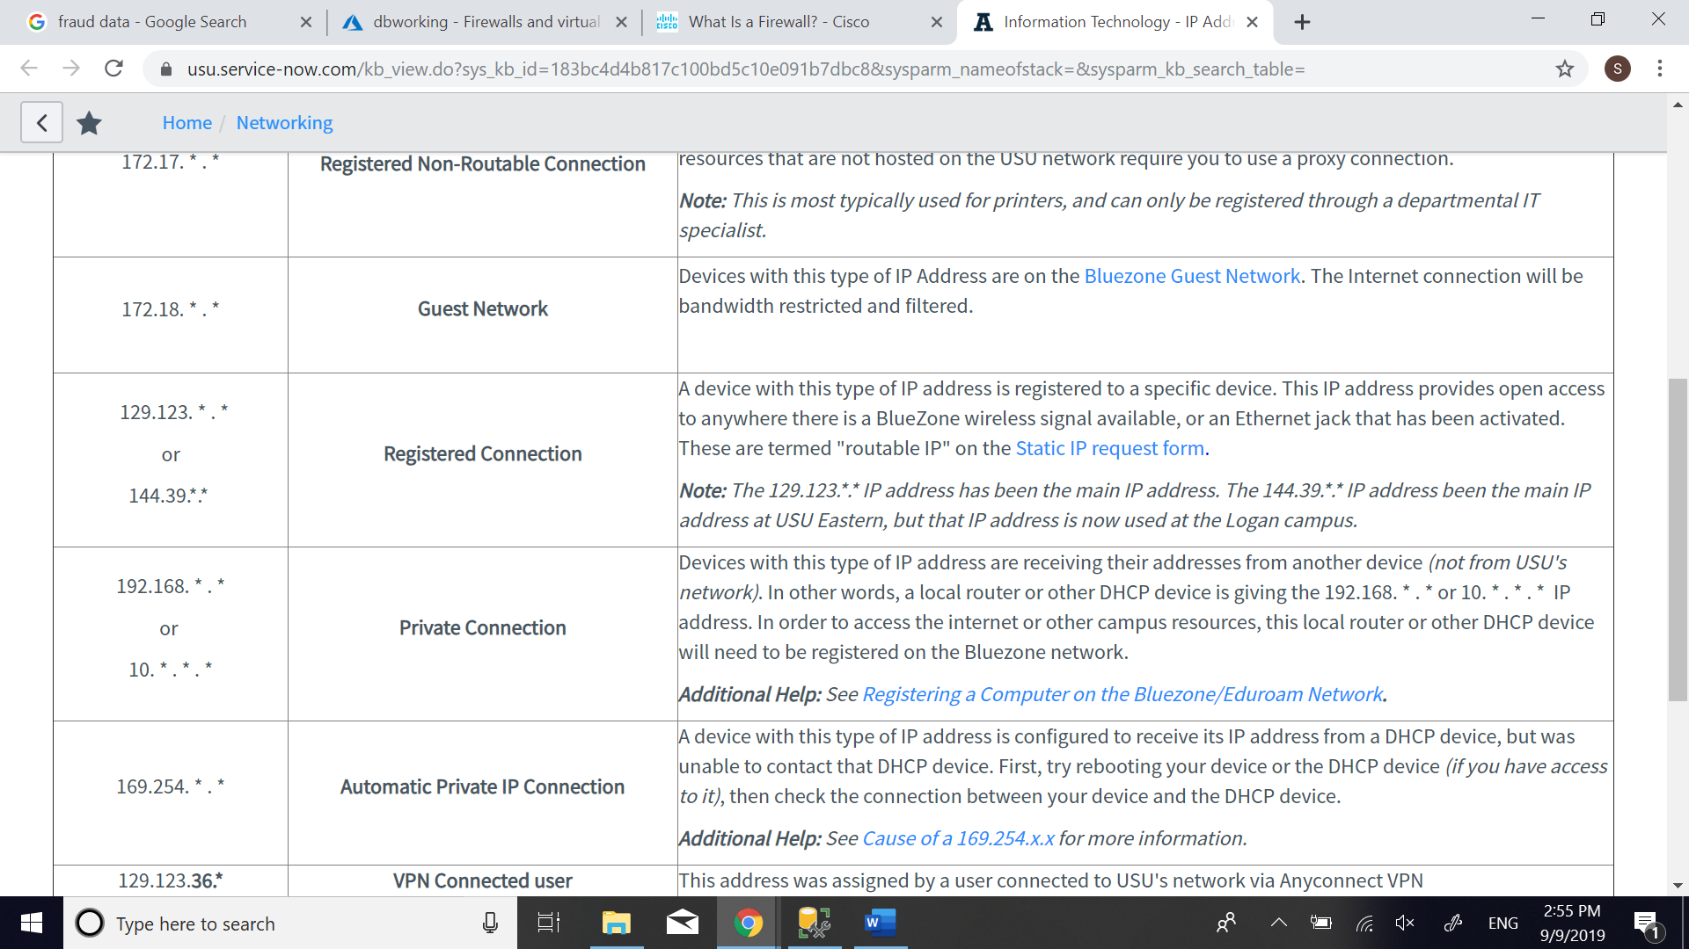

After you get the ip address, go to your Azure portal. Click “See all your resource”.

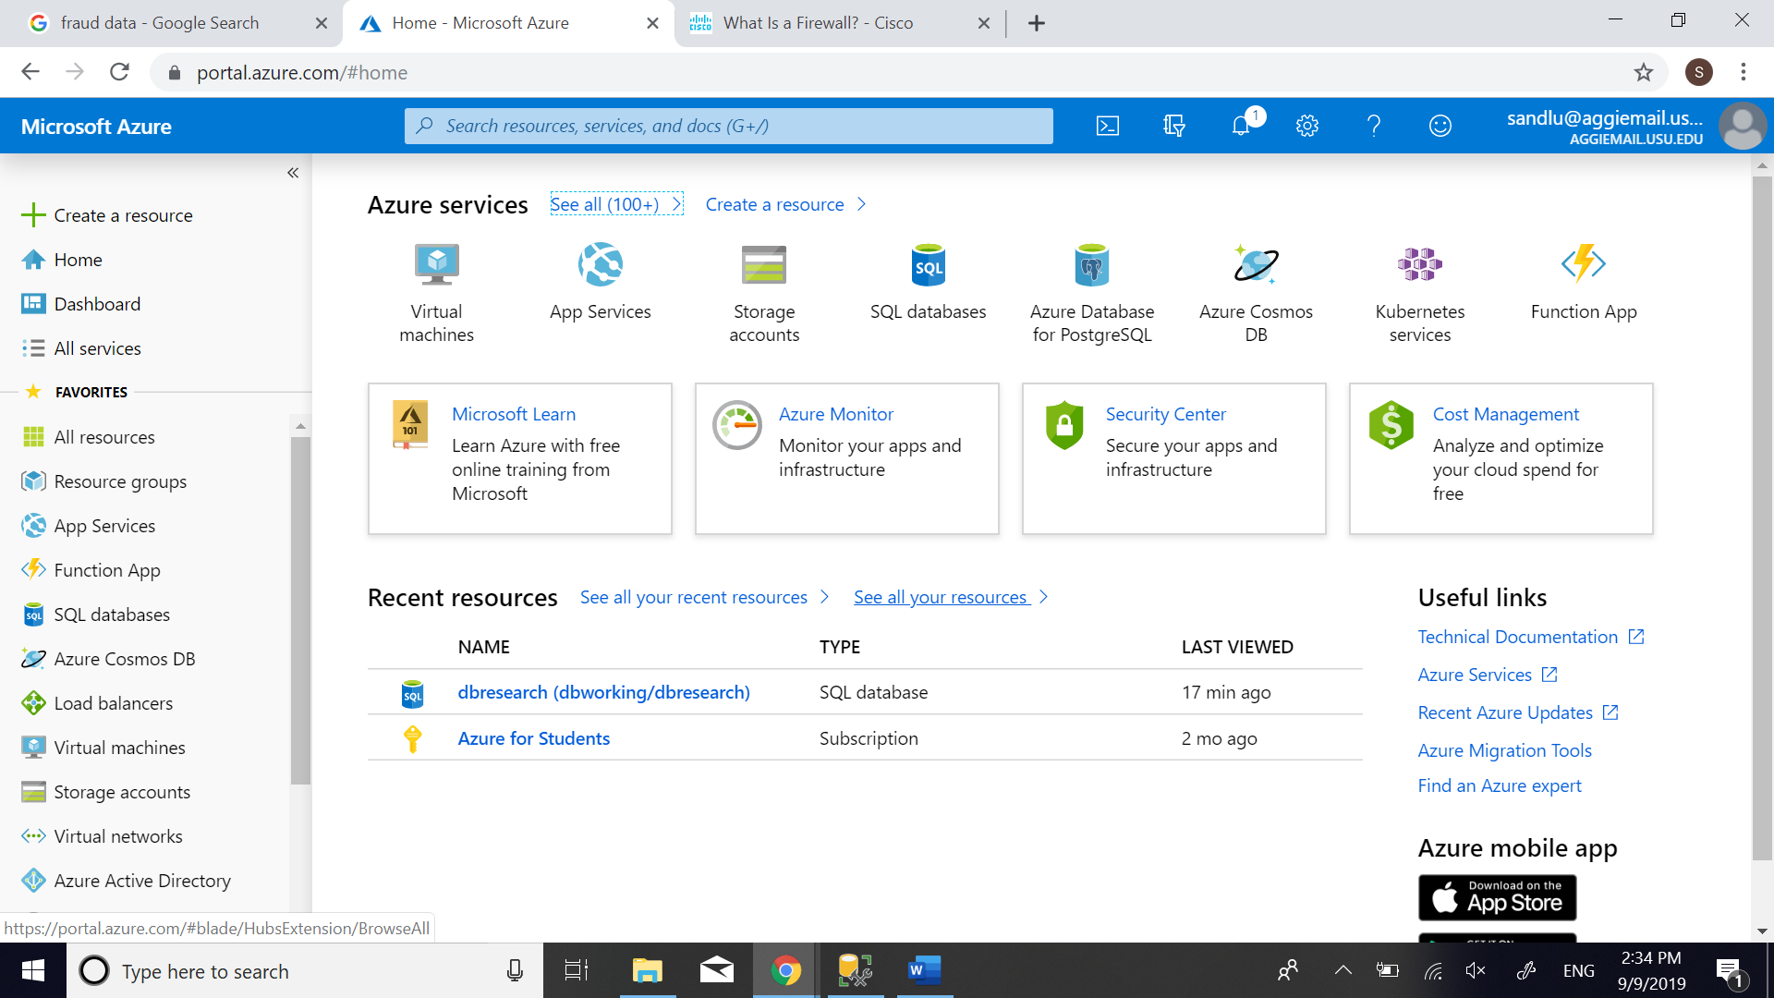

Click on your SQL server.

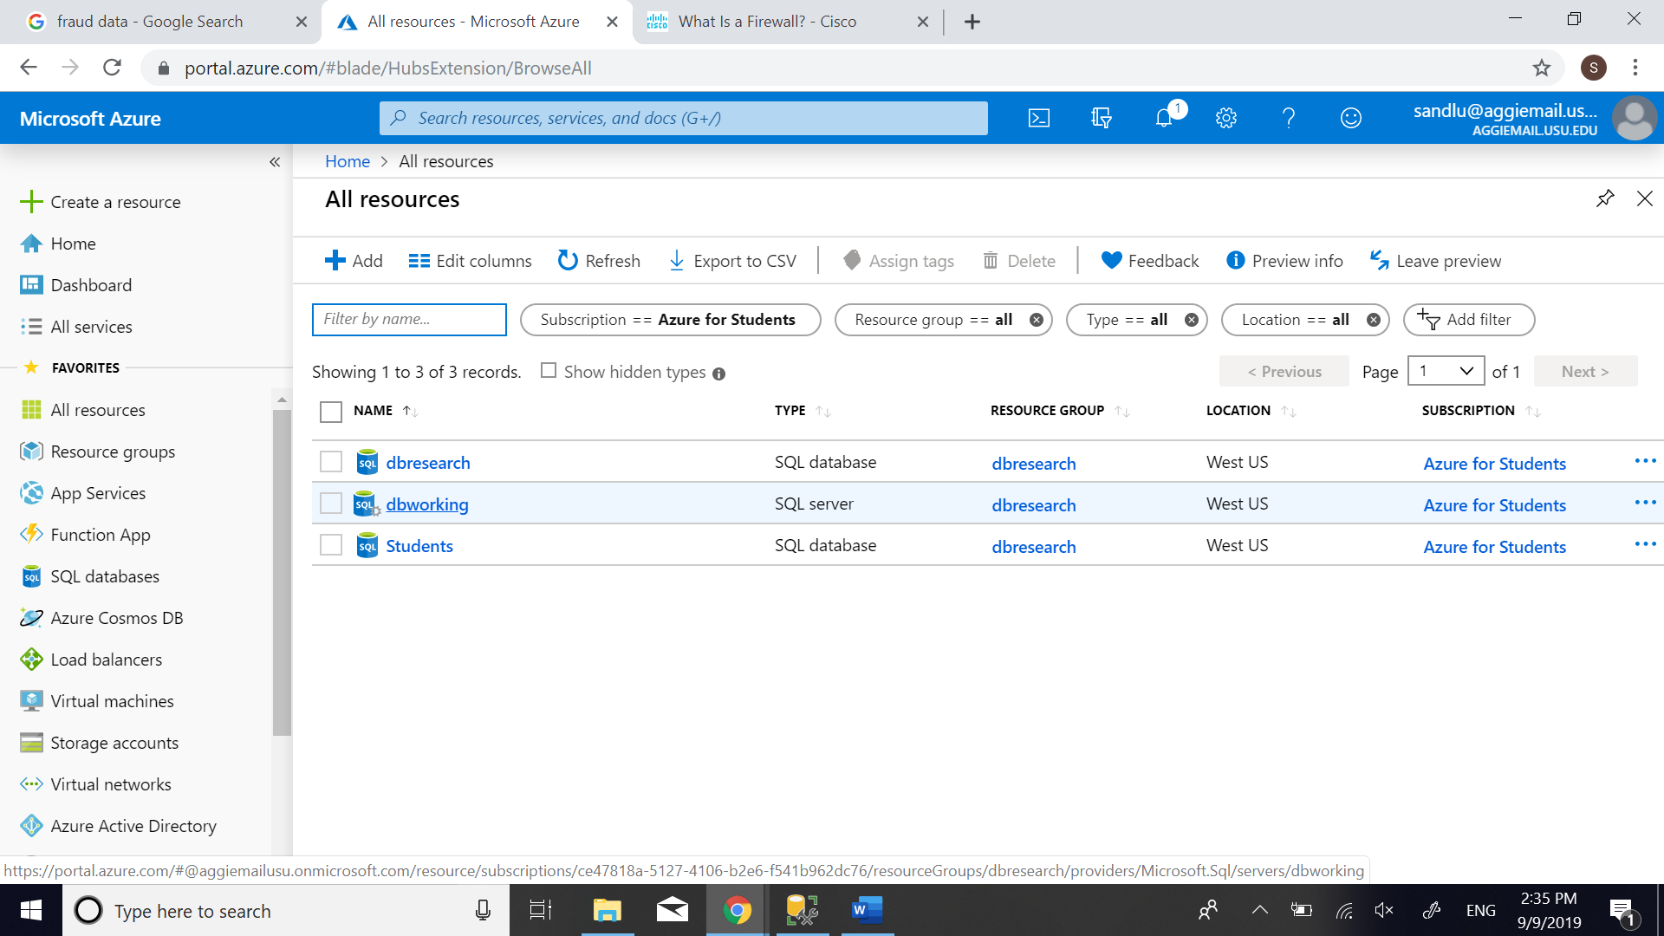

Click “Show Firewall settings”.

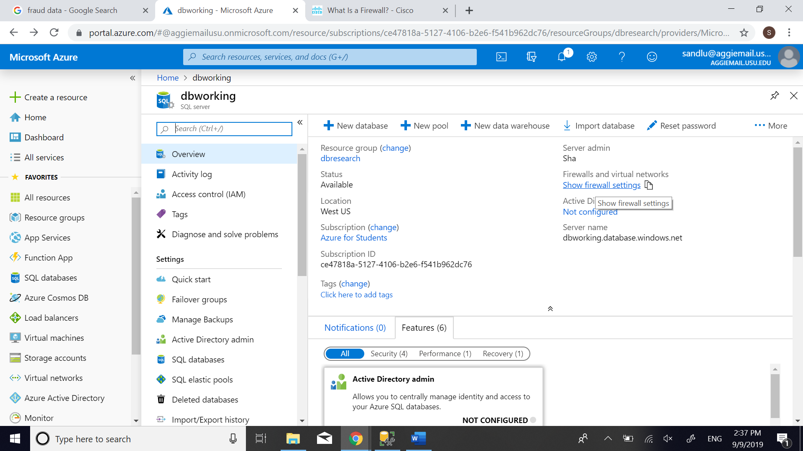

As we mentioned before, there are two types of IP address for registered connection: 129.123. * . * and 144.39.*.*. Give them reasonable names, type the START IP and END IP, then click Save.

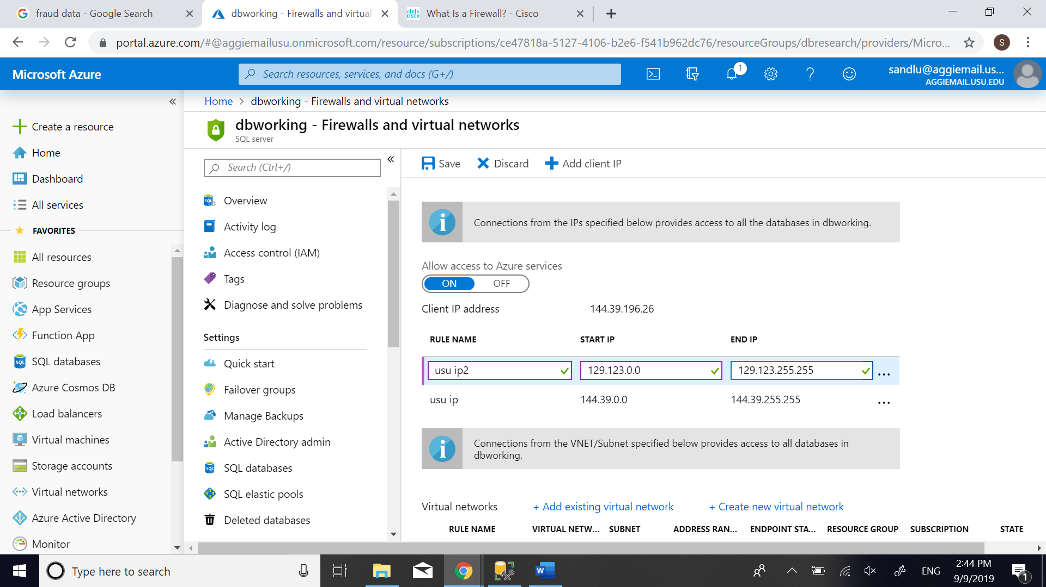

When the server firewall rules are saved successfully, you can see the notification as showing below. Then click OK. You can go back to SSMS and log in again.

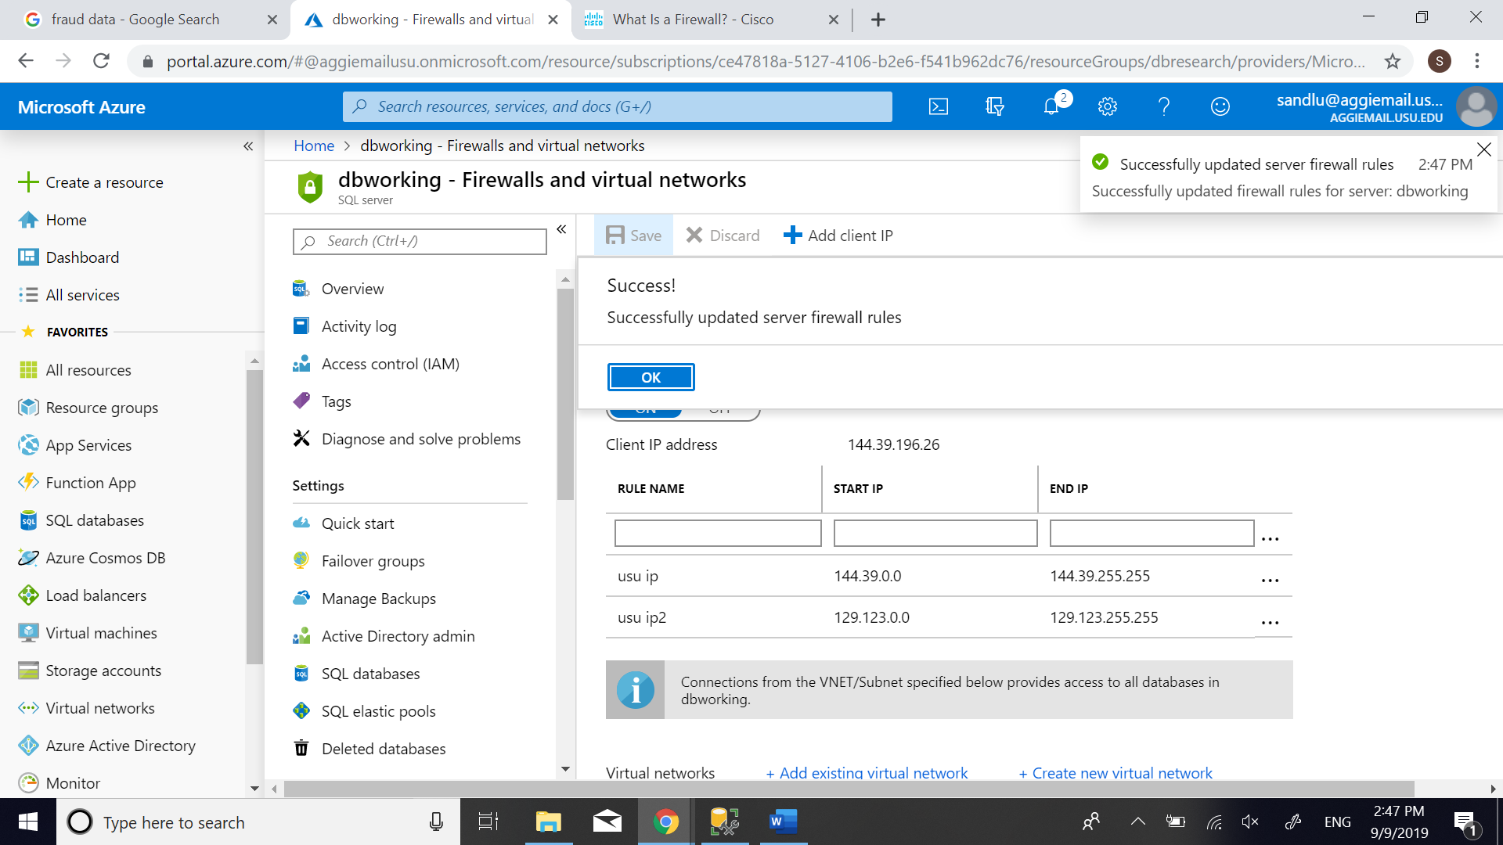

After setting up the firewall rules, you can login successfully without being asked to sign in your Azure account now.

